**Team: Atomic Thunder**

**Architecture Design:**

For designing the architecture of Align, we designed a Model-View-Controller (MVC) architecture. This architecture was chosen due to its clear separation of concerns, which simplifies development and maintenance. The MVC pattern allows for parallel development, with team members able to work on different components simultaneously. It also facilitates code reusability and enhances testability. Given that Align is a web application with various interactive components that need to respond to user inputs, MVC provides an ideal structure for managing the complexity of the system while keeping the code organized and maintainable.

**Architecture Design Diagram**:

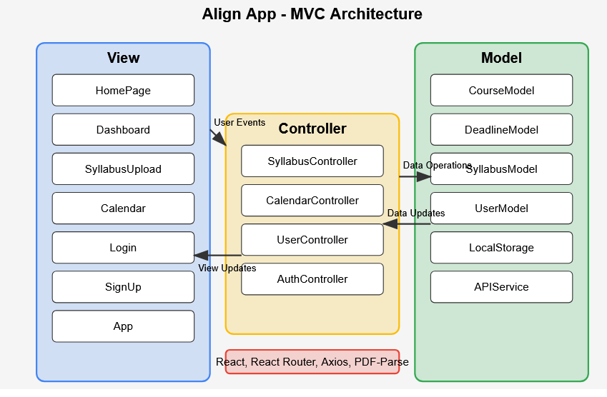

**Design Description:**

The architectural pattern consists of three components, the view, the controller and the model:

*View*

The View for Align handles the UI of the web application. This is primarily implemented using React and React Bootstrap. The View layer consists of the multiple components that can be displayed to users.

Any interaction with the UI triggers user events sending information to the Controller to handle the inputs. React Router is used for navigation between different views, and React Bootstrap provides consistent styling throughout the application.

### *Controller*

The Controller handles the various events from the View. When user input is detected, such as uploading a syllabus or requesting to view the calendar, the Controller processes these events, notifies the View of any necessary changes, and communicates with the Model for data operations.

The Controller layer uses PDF-Parse for syllabus text extraction and implements the business logic for organizing and interpreting extracted data.

### *Model*

The Model for Align handles the data storage and management for the application.

The Model notifies the Controller of any data changes, allowing the View to be updated accordingly. This communication between the database and the Controller is essential for keeping the application's information current and synchronized across different views.

This MVC architecture provides Align with a structured approach to development, clearly separating data management, business logic, and presentation concerns. The separation allows for easier maintenance, testing, and future enhancements of the application.